**REVAMPING SCRUTINY THROUGH RTI**

Final Year Project Report

by

Hafiz Muhammad Uzair

Shaiza Mann

In Partial Fulfillment

Of the Requirements for the degree

Bachelors of Science in Computer Science (BSCS)

School of Electrical Engineering and Computer Science

National University of Sciences and Technology

Islamabad, Pakistan

(2019)

REPORT: REVAMPING SCRUTINY THROUGH RTI

**DECLARATION**

We hereby declare that this project report entitled “REVAMPING SCRUTINY THROUGH RTI” submitted to the “DEPARTMENT OF COMPUTING”, is a record of an original work done by us under the guidance of Supervisor “Dr. Arsalan Ahmad” and that no part has been plagiarized without citations. Also, this project work is submitted in the partial fulfillment of the requirements for the degree of Bachelor of Computer Science.

| **Team Members** | | **Signature** |
| --- | --- | --- |
| Hafiz Muhammad Uzair | | \_\_\_\_\_\_\_\_\_\_\_\_\_\_ |
| Shaiza Mann | | \_\_\_\_\_\_\_\_\_\_\_\_\_\_ |
| **Supervisor:** | | **Signature** |
| Dr. Arsalan Ahmad | | \_\_\_\_\_\_\_\_\_\_\_\_\_\_ |
| **Date:** | |  |
| 24–04–2019 |  |  |

**Place:**

School of Electrical Engineering and Computer Science

REPORT: REVAMPING SCRUTINY THROUGH RTI

**DEDICATION**

To all those who have supported, encouraged ,challenged and inspired us. And specially to our honorable teachers and friends for all their guidance and attention which has helped us to make up to this point and as well as the continuous training sessions which helped us build courage , awareness and commitment to follow the best possible route , by their unmatchable style.

REPORT: REVAMPING SCRUTINY THROUGH RTI

**ACKNOWLEDGEMENTS**

In completion of this graduate project we have been fortunate to have help, support and encouragement from many people. We would like to acknowledge them for their cooperation.

First, we would like to thank Dr. Arsalan Ahmad, our project supervisor, for guiding us through every step of the process with knowledge and support. His sage advice, insightful criticisms, and patient encouragement aided the completion of this report and project in innumerable ways. We would like to also thank Dr. Safdar Abbas Khan, Co-advisor of our project, whose steadfast support of this project was greatly needed and deeply appreciated. Thank you for your ideas, guidance and assistance. We would like to dedicate this project to our lecturers, and everybody else for their encouragement and help throughout the project.

We would also like to thank our colleagues at SEECS for their constructive criticism and discussions of final year project.

Finally, we would also like to thank the Department of Computing for giving us the chance to conduct this final year project. From this project, we were able to gain vast knowledge for our future in the Information Technology world.

REPORT: REVAMPING SCRUTINY THROUGH RTI

**Contents**

[DEDICATION 3](#_3znysh7)

[ACKNOWLEDGEMENTS 4](#_2et92p0)

[ABSTRACT 9](#_4d34og8)

[INTRODUCTION 11](#_17dp8vu)

[1.1 PROJECT SIGNIFICANCE 14](#_26in1rg)

[1.2 PROJECT LIMITATION 15](#_35nkun2)

[1.1 REPORT ORGANIZATION 15](#_1ksv4uv)

[LITERATURE REVIEW 16](#_2jxsxqh)

[PROBLEM DEFINITION 19](#_3j2qqm3)

[METHODOLOGY 20](#_4i7ojhp)

[Initial Approach 21](#_1ci93xb)

[Current Approach 22](#_3whwml4)

[Dataset 24](#_qsh70q)

[Algorithmic Approach 24](#_3as4poj)

[Tools & Techniques 26](#_1pxezwc)

[DETAILED DESIGN AND ARCHITECTURE 28](#_2p2csry)

[5.1 SYSTEM ARCHITECTURE 28](#_147n2zr)

[5.1.1 Architecture Design Approach 29](#_23ckvvd)

[5.1.2 Architecture Design 29](#_ihv636)

[5.1.3 Subsystem Architecture 29](#_32hioqz)

[5.2 DETAILED SUB-SYSTEM 31](#_2grqrue)

[5.2.1 Classification 31](#_vx1227)

[5.2.2 Definition 31](#_3fwokq0)

[5.2.3 Responsibilities 31](#_1v1yuxt)

[5.2.4 Constraints 31](#_4f1mdlm)

[5.2.5 Composition 31](#_2u6wntf)

[5.2.6 Uses / Interactions 32](#_19c6y18)

[5.2.7 Resources 32](#_3tbugp1)

[5.2.8 Interface / Exports 32](#_28h4qwu)

[ANDROID APPLICATION SYSTEM DETAIL 35](#_1mrcu09)

[5.3.1 Classification 35](#_46r0co2)

[5.3.2 Definition 35](#_2lwamvv)

[5.3.3 Responsibilities 35](#_111kx3o)

[5.3.4 Constraints 35](#_3l18frh)

[5.3.5 Composition 37](#_4k668n3)

[5.3.6 Uses / Interactions 37](#_2zbgiuw)

[5.3.7 Resources 37](#_1egqt2p)

[5.3.8 Interface / Exports 37](#_3ygebqi)

[INTELLIJ SYSTEM DETAIL 43](#_1rvwp1q)

[5.3.1 Classification 43](#_4bvk7pj)

[5.3.2 Definition 43](#_2r0uhxc)

[5.3.3 Responsibilities 43](#_1664s55)

[5.3.4 Constraints 43](#_3q5sasy)

[5.3.5 Composition 43](#_25b2l0r)

[5.3.6 Uses / Interactions 43](#_kgcv8k)

[5.3.7 Resources 43](#_34g0dwd)

[5.3.8 Interface / Exports 44](#_1jlao46)

[5.3 CLASS DIAGRAM 46](#_2iq8gzs)

[IMPLEMENTATION AND DESIGN 47](#_3hv69ve)

[6.1 IMPLEMENTATION 47](#_1x0gk37)

[6.2 TESTING 49](#_2w5ecyt)

[RESULT AND DISCUSSION 50](#_3vac5uf)

[7.1 Results 51](#_pkwqa1)

[7.1.1 Testing Result 51](#_39kk8xu)

[7.1.3 ANDROID APPLICATION INTERFACE RESULTS 54](#_48pi1tg)

[7.1.4 RESEARCH PAPERS 54](#_2nusc19)

[CONCLUSION AND FUTURE WORK 55](#_3mzq4wv)

[REFERENCES 56](#_haapch)

**LIST OF FIGURES**

Figure 1 - Object detection from RSS feed ------------------------------------------------------- 17

Figure 2 - Principles of Trilateration ---------------------------------------------------------------17

Figure 3 - Nodes placement for experimental setup ----------------------------------------------18

Figure 4 – Waterfall Model --------------------------------------------------------------------------19

Figure 5 - Localization with Wi-Fi------------------------------------------------------------------ 20

Figure 6 - Wi-Fi setup being used for defense----------------------------------------------------- 21

Figure 7 - Current Approach -------------------------------------------------------------------------21

Figure 8 - System Architecture ----------------------------------------------------------------------22

Figure 9 - Tools & Techniques ----------------------------------------------------------------------25

Figure 10 - Subsystem Architecture----------------------------------------------------------------- 29

REPORT: REVAMPING SCRUTINY THROUGH RTI

# **ABSTRACT**

Indoor positioning system is a concept which refers to tracking an object in an indoor system in real time. In this time of technological globalization, plenty of applications exist where the localization of indoor environments is just as important as monitoring and tracking in outdoor environments. Where outdoor monitoring scenarios make use of Global Positioning Systems (GPS) due to its ease of implementation and greater accuracy, indoor environments pose unsolvable challenges for the deployment of GPS systems to localize objects due to confined spaces and presence of various obstacles found indoors. Thus, precise localization of objects in indoor environments is a challenge yet to be smartly addressed. In this report, we bring forward a novel idea built upon Wireless Sensor Network (WSN) and signal processing which makes use Cartesian-Coordinate system and two-line intersection formula to project the object’s precise location in an indoor environment on an Android application. The purpose of this system is to bring about a cost and energy-efficient alternative to the traditional approaches that are presently being used to attain security in indoor environments.

A data set already obtained from several experiments has been used for this project. The development of the algorithm involved the formation of clusters for each node in a setup and the comparison of the obtained values with the result-based threshold.

Instead of producing a tomographic image, a diagrammatic figure is displayed as the real-time project from where the object(s) might be on the user's mobile phone screen.

To get accurate results, however, training the algorithm required a hit and trial method. The distortions within signals and multiple nodes falling into the same cluster values resulted in a slower response time that was eliminated through regular programming practices, making the designed algorithm more efficient.

The scope of the project is currently limited to pre-set data set without giving the user flexibility to test out just any environment. However, by setting up radio transmitters and collecting live data to train the currently designed algorithm, the project can be carried out further. To further entail more technology, signal processing filters can be used to demonstrate results on the mobile phone screen as a captured image.

REPORT: REVAMPING SCRUTINY THROUGH RTI

***Chapter 1***

**INTRODUCTION**

In this contemporary and evolving world, security has become more indispensable than ever. Today, it is one of the rapidly advancing industries all over the globe. When it comes to talking about a security of an area, suitable measures are ensured for the safety of individuals and materials in a vicinity be it an organization, home or any building that requires constant monitoring, this includes the security of highly restricted areas. Almost every day, we hear about damage or loss occurring due to security lapses or a lack of security in general. A home burglary occurs every 13 seconds. The Bureau of Justice under US Department of Justice declared in their statement that 3.7 million households face break-ins every year, which contributes to approximately 3% of houses being burglarized annually. In a similar way, soldier martyrdom rates in terrorist combat cases have seen a recent highest total of 8,584 acts of terrorism, worldwide. This brought about 18,700+ mortalities and injuries of about 19,400 people in 2017. The above mentioned statistics could be greatly reduced if a system is deployed to detect and localize terrorists in a target building.

Thus, securing and protecting their property is a primary concern of all individuals. For the last decade, vast amount of research and development of mediums to secure external environments has led to the achievement of outdoor security goals. Indoor security procurement, however, has still remained relatively unaddressed.

Technology has seen the emergence of numerous localization techniques, the majority of which rely on global position systems (GPS), surveillance cameras, wireless networks, radio frequency identification (RFID) and global satellite network systems (GSNS) among others. Majority of these techniques rely on the strength of the network or radio signals especially if the localization is targeted in enclosed environments. Furthermore, wireless fadings, perpetual NLoS conditions and multipath RF signal dissipation pose numerous difficulties in creating a reliable and accurate localization framework.

Most commonly used smart indoor security systems deploy surveillance cameras for object localization. A camera can only observe a limited area as the obstacles cannot be looked through and thus requires an additional number of hardware. Also, presence of an individual is constantly required to monitor the screens for intrusion detection in internal territories. In addition, cameras can be destroyed or altered easily and fail to perform their function in the dark. Hence, with the swift growth of wireless products, a humongous increase in the need for radio-frequency (RF) signals has arisen to detect and localize objects in indoor environments. With RF signals, physical objects in an indoor network always create attenuation and thus it is imperative to have a mechanism in place that helps to improve the localization process. There are various techniques being followed to implement the concept of detection and localization of moving/stationery object(s).

The most widely discussed technique that has been followed in several researches is the application of Radio Tomographic Imaging to project the final results to the user. [1] Another approach focused on making use of received signal strength and its associated induced-variance projected through a wireless nodal network and Kalman Filter Tracking to eliminate noise and obtain exact location of detected objects. [2] Other techniques use kernel distance, network radio frequency detection or geometric methods like that of trilateration to close down in on object’s exact location.

Keeping in view the work that the above-mentioned researches carried out, our project aims to eliminate the use of radio tomographic imaging and use Cartesian-coordinate system in combination with two-line intersection formula for localization purposes. A straight forward algorithm based on the attenuation of radio signals caused by stationary or moving object(s) has been deployed which displays results to the user on a regular Android application. Considering the work being currently conducted in the said domain and with this being an emerging field with a vast range of application, this research paper puts forward an unprecedented and efficient algorithm to localize objects, with an improved accuracy.

Here is how the project aims to work:

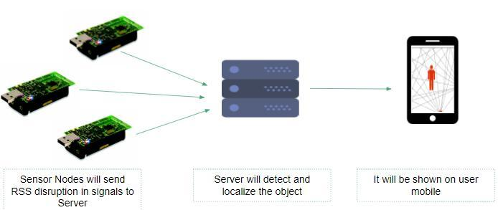

REPORT: REVAMPING SCRUTINY THROUGH RTI

# **1.1 PROJECT SIGNIFICANCE**

The main objective of this product development is to provide tracking of objects (without any sensors) in a wireless network to provide detection in emergencies, rescue operations and security breaches.

Looking deeply into the comparison with surveillance cameras:

* A camera can only observe a limited area as it is not possible to look through the obstacles and would require additional hardware.
* To monitor the screens, a constant presence of an individual is mandated; however in this case an android phone with the installed application is adequate.
* Particularly in comparison to radio transmitters in an area, cameras can be easily destroyed or altered.

Application for this system is not limited to corporations seeking security or individuals wanting to secure their homes. Rescue services are estimated to be the main benefit. When we talk about disasters like earthquake, flood, etc., it is very evident that the cameras or any similar security measure used will be rendered useless due to destruction; in that case a quick solution is needed to get out of the critical situation. The rescue / security forces can therefore place the transmitters around an area and quickly determine the location of the buried individuals.

REPORT: REVAMPING SCRUTINY THROUGH RTI

# **1.2 PROJECT LIMITATION**

A few constraints were taken into account when developing the product for the successful completion of the project.

* Radio transmitter inaccessibility due to high costs
* Rigorous training method to ensure 100% accuracy on raw data-set
* Reduced accuracy with increased movement of people
* Speed of moving people effects accuracy
* Complete noise removal due to fluctuations in RSS signals

# **1.1 REPORT ORGANIZATION**

The objective of this report is to develop a depth of understanding of project's purpose, what the project is about, as well as how the project will be implemented. First, a brief introduction sheds some light on the use and significance of the project; a few constraints were also highlighted to facilitate further use by any individual. A literature review, which was discussed next in the report, was also carried out as part of this research project. Also mentioned are meticulous paradigms followed by the project along with the architecture details of its system and its implementation and testing of the code developed by utilizing various frameworks.

REPORT: REVAMPING SCRUTINY THROUGH RTI

***Chapter 2***

**LITERATURE REVIEW**

In recent years, in order to make an optimal indoor localization model, multiple interventions have been generated. A perfect framework would be useful if it can be generically applied to various environments and could monitor multiple objects with low inaccuracy. In order to assess the optimum wireless technology for indoor tracking, one of Joey Wilson and Neil Patwari's methodologies revolves around the use Radio Tomography for object location by planting radio transmitters around the object to be identified and exploiting RSS feeds from those transmitters to track down the object, as depicted by the Fig.1. They enacted a stochastic model to evaluate the strength of a signal or RSS obtained. Wilson and Patwari model goes on to include the discussion of an approach used to estimate the image position known as Tikhonov regularization. The issue of noise being detected among the received signals is obliterated by passing it through a Gaussian Noise Model. [1]

Other techniques of object tracking utilize trilateration algorithms as in the Fig.2. Trilateration measures distance from the anchor nodes to the sensor node, which is a transmitter itself, to track its coordinates. Trilateration Algorithm's estimation techniques include measurements like that of Time of Arrival (ToA), Time Difference of Arrival

(TDoA) and Received Signal Strength Indicator (RSSI). For trilateration to be performed, it is must know the position of at least three transmitter nodes for the initial run. This particular technique has a limited domain of application in that it requires for the object being tracked to be a transmitter itself, which, for practical reasons, cannot always be the case. [3][4][5]

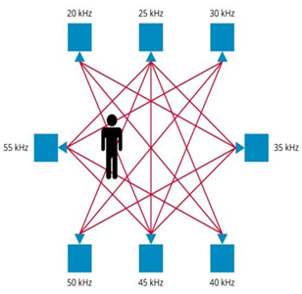

Another strategy used by researchers to track objects as accurately as possible is to use scene analysis in an enclosed environment. M. Rudinac et al. illustrated a scene probing method for distinguishing regions of interest in unidentified indoor areas and quantifying the location of objects in those areas. There were two stages in their method: First, they created a scene saliency map based on the 3 color spectral residual and distinguished regions of interest (RoI) in this map. Second, a strategy for clustering neighboring RoI, discarding outliers and highlighting the positions of potential objects was proposed. Once the position of objects within the ROI is known, object's class recognition is performed. [6]

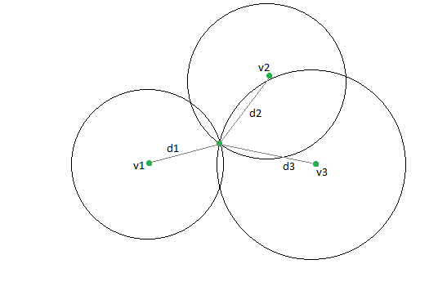

**Figure 2 - Principles of Trilateration**

Zheng and Men [7] advocated a framework that is similar to Wilson and Patwari's model and that can track or locate an object through a wall. Fig.3 [7] describes and illustrates the experimental setup for the proposed system to be used for through wall tracking. The framework utilizes the variation-based parameters of a moving object in combination with real-time measurements in the underlying network. The framework is modelled using the fact that it is possible to use the Gaussian process to assess the features of RSS distribution. The model is able to determine when the links to various nodes are affected by having an algorithm updated online to reflect the real-time changes. Additionally, the model uses Monte Carlo Simulation to track and determine the location of the moving object.

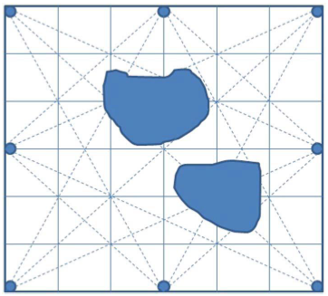

**Figure 3 - Nodes placement for experimental setup**

In this project, after conducting an extensive literature review, we expand on the approaches discussed above and put forward a unique and simple solution to localize stationary and moving objects by using RF signals and their attenuation caused by objects in an enclosed environment to obtain accurate 2-dimensional coordinates of the tracked object, obtained from equalizing equations of the transmitters facing attenuation.

REPORT: REVAMPING SCRUTINY THROUGH RTI

***Chapter 3***

**PROBLEM DEFINITION**

When talking about an area's public safety, necessary precautions are designed to ensure the safety of people and resources in a vicinity, be it an institution, residence or any building that requires regular monitoring, this encompasses the security of highly restricted areas, e.g. military bases.

Authorities seeking to implement security protocols are also aiming for budget-effective alternatives and those that deliver accurate and quick results. To address these security concerns and taking into consideration the limited facilities provided by conventional methods, such as CCTV cameras, lays the development of this product.

*“Revamping Scrutiny through RTI”* presents a real-time tracking scheme for object detection and localization in an environment by manipulating and processing the radio signals. The results will be projected on a user friendly android application to allow easy observation of results in a timely and cost-efficient manner. This document describes in detail the functional and nonfunctional requirements of our project along with the strategies developed and followed to achieve the said goal.

REPORT: REVAMPING SCRUTINY THROUGH RTI

***Chapter 4***

**METHODOLOGY**

The Development Life Cycle used for this system design and development contains the following methodology:

1. Requirements Gathering 2. Analysis based on the Collected Data   
3. System Design 4. Software Development   
5. Software Testing 6. Software Deployment

Before the system's final test, these phases were iterative. The system follows a series of phases from requirement, system and software design definition to implementation and system testing and integration. A thorough competitive analysis was included in the first phase. Requirement collection was done after extensive survey and questionnaires and interviews were conducted. The product was then formed.

Each project follows a formal rubric for its enactment, and different methodologies are used for software development, including the System Development Life Cycle (SDLC), spiral, prototyping, Agile ETC. We have followed the Waterfall model as shown in the Figure for our software development strategies.

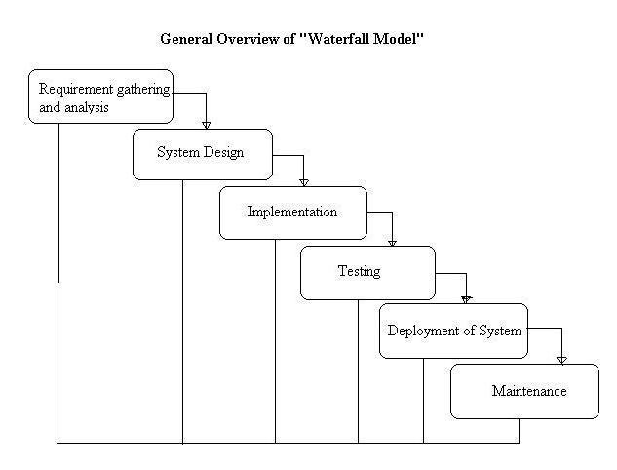

**Figure 4 – Waterfall Model**

REPORT: REVAMPING SCRUTINY THROUGH RTI

# **Initial Approach**

To produce a cost-effective and easy-to-use object localization system, initial approach consisted of using Wi-Fi routers and the attenuation of radio signals emitted by them to project the location of detected object(s) on a user interface, as depicted by Fig. 5. Wi-Fi routers hinted towards an affordable solution due to their ubiquitous presence almost everywhere. However, this approach failed to work optimally due to multiple reasons. Precise results were difficult to attain due to the turbulent nature of wireless signals.  Also, as the initial setup was not arranged in a secluded environment where the specific access points, constituting a wireless network, could have been pre-known, it was difficult to gauge which specific routers were emitting the attenuated RSS feed. Additionally, as the routers in discussion emanated signals in an omnidirectional manner, any object disrupting their field even from outside the network attenuated their signals and hence, led to an incorrect generation of results. Since, majority of these devices belonged to Cisco or TP-Link, their non-configurability made it even harder to enable these routers to produce signals directionally, so as to remain just inside the wireless network. Fig.6. [8] Lastly, using Wi-Fi routers to achieve the goal of object detection and localization was hindered also because of the fact that buying routers that gave off radio signals in a particular direction would have increased the cost to twofold in comparison with the cost of Telosb radio transmitters, which negated our very aim of establishing a cost-effective system.

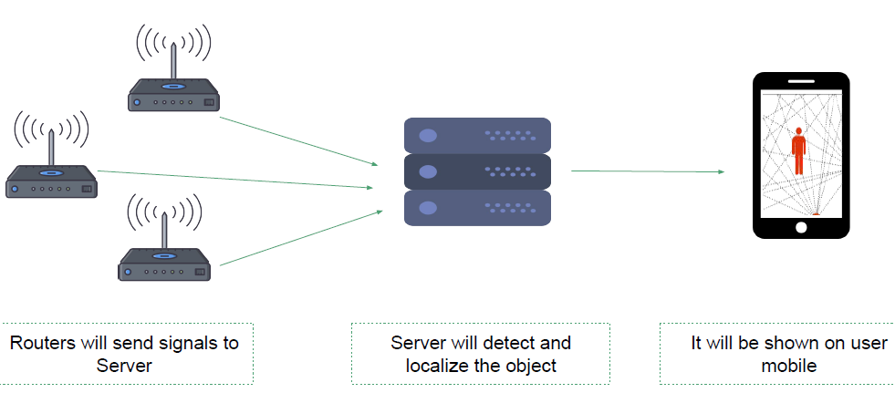

**Figure 5 - Localization with Wi-Fi**

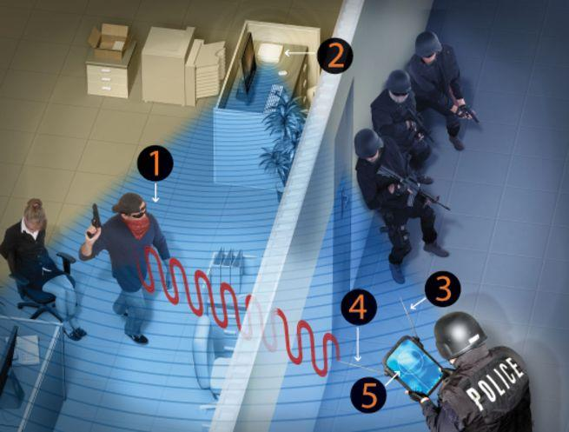

**Figure 6 - Wi-Fi setup being used for defense**

# **Current Approach**

Radio transceivers emit signals that pass through walls and furniture to reach other transceivers within the network. In the network, when a person moves, his/her body interrupts the signals, and the person is located by our algorithm. The person being sensed does not wear or carry any device. These attenuated RSS values are sent to a centralized server where a running algorithm calculates the system and hence displays it on the user’s mobile phone screen on an Android application. Current approach is visually explained by the Fig. 7 and 8 below.

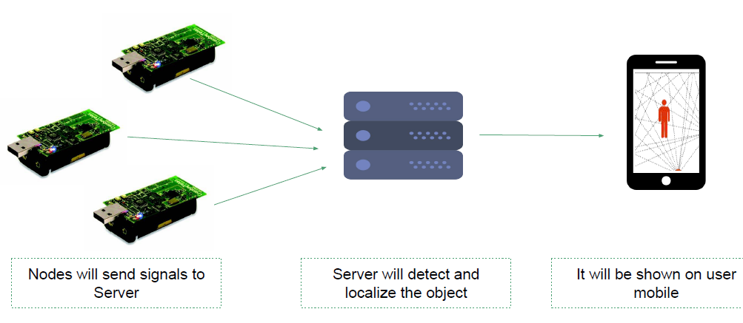

**Figure 7 - Current Approach**

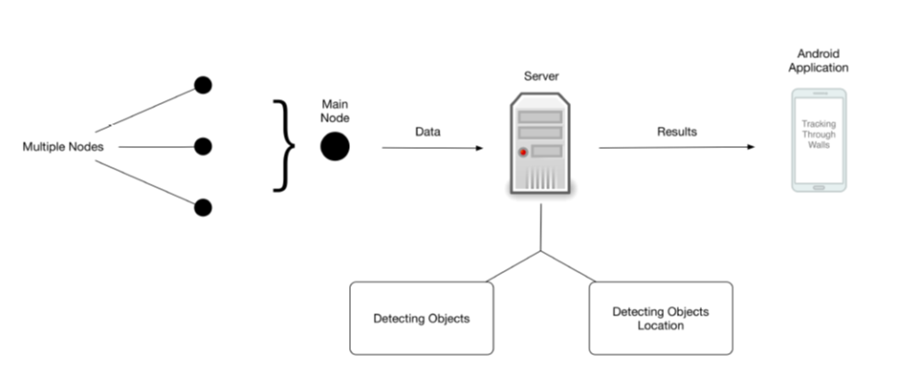

# **Dataset**

The dataset for this experiment was obtained from University of Utah, SPAN Lab’s 2010 Outdoor RTI Data Set [1] and 2013 Through-Wall RTI Data Set. [9]

This dataset was constructed by placing 28 nodes or radio transmitters around a rectangular area with a distance of 3 meters between each node. These nodes transmit RSS values, depending upon the attenuation or signal obstruction caused by stationary or moving objects in this wireless network.

Various types of experiments were performed by Joey Wilson and Neil Patwari to obtain this dataset:

* Empty Room Setup
* One object, stationery
* One object, moving
* Two objects, stationery
* Two objects, moving
* Three objects, stationery
* Three objects, moving

# **Algorithmic Approach**

For this project, the data set, mentioned above, obtained by several experiments was used. The algorithm involved forming clusters for each node placed in the setup and then comparing the obtained values with the threshold that was set based on the results acquired from various experimental setups, to eliminate noise. Two-dimensional geometric lines are then generated between the respective radio transmitter nodes which have distortion greater than the noise threshold. Cartesian coordinates of all the nodes included in the experimental setup are already known from the dataset and are fed into the algorithm. The two-point formula to obtain equation of the line passing through the points (x1,y1), i.e. node 1 and (x2,y2), i.e. node 2, between nodes with RSS values greater than noise threshold in the Cartesian plane is given by

 y-y_1=(y_2-y_1)/(x_2-x_1)(x-x_1), 

or conversely,

 y-y_2=(y_2-y_1)/(x_2-x_1)(x-x_2). 

The obtained equations are equated in sets of two to obtain multiple intersection points, indicating the location of a detected object. All nodes in the wireless network then check for the number of neighboring intersection points they have. All those intersection points which are close in proximity to a large number of nodes or transmitters in the network are then selected by the algorithm and average is taken of their x- and y-coordinates, respectively. Results obtained after averaging the intersection points give exact coordinates of the localized object or object(s). Instead of producing a tomographic image as was done by Joey Wilson and Neil Patwari [1][9], a diagrammatic figure is displayed on the user’s Android application screen as a projection of real-time position of localized objects.

Algorithmic approach deployed to locate objects is demonstrated by the flow chart below:

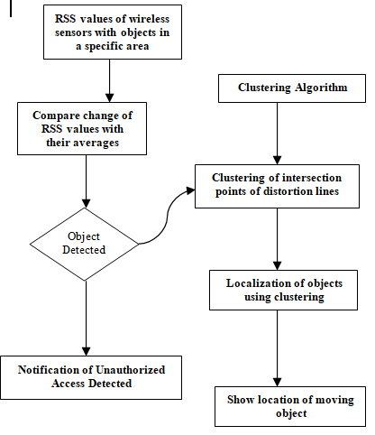

# **Tools & Techniques**





* **Android Studio –** to display results to users through an android application
* **Firebase –** cloud database storage to connect android app with nodejs server where much of the processing takes place
* **Netbeans & Nodejs –** to execute the algorithm and compute coordinates of located objects
* **Insider –** used in initial approach taken to test detection of objects using laptops receiving Wi-Fi signals from multiple access points

REPORT: REVAMPING SCRUTINY THROUGH RTI

***Chapter 5***

**DETAILED DESIGN AND ARCHITECTURE**

# **5.1 SYSTEM ARCHITECTURE**

The basic outline of the devised research project is primarily focused on the communication between two different servers in order to implement sufficient procedures, in this case the Android application, to produce results on the client side. Looking deeper into the architecture of the system, the main objective of the software side is to collect RSS values from radio transmitters and then to project results on a UI. The following architecture focuses on connecting the transmitting end to that f client's. A running application server is used for this purpose to process the relevant information and transmit it to the display of the user.

A NodeJS server carries out the process of calculating intersection points, forming clusters and then determining the accurate results. The server communicates with Firebase Cloud Messaging which sends updated location on the Android app and prompts the user about the updates via push notifications, indicating the detection of object(s), and the Android app displays the results to the user.

REPORT: REVAMPING SCRUTINY THROUGH RTI

## ***5.1.1 Architecture Design Approach***

The Node.js server operates as the main building block, responsible for accurately evaluating results and also focuses on presenting the user with real-time information. These calculated results are sent by an intermediate system to the android application model, which is the Firebase that ensures that updated results are provided to the user.

## ***5.1.2 Architecture Design***

The architectural design of the system symbolizes how each module is connected in order to provide useful information and the data needed to produce precise results. Glancing into the NodeJS server, it contains components essential to evaluate the intersection points, form clusters and then determine the exact results. On the other hand, the android application's java code focuses on displaying results to user in a user-friendly manner.

## ***5.1.3 Subsystem Architecture***

The dataflow diagram of the entire architecture is as follows:







**Figure 10 - Subsystem Architecture**

Details of sub-systems:

* **Android Studio –** to display results to users through an android application
* **Firebase –** cloud database storage to connect android app with nodejs server where much of the processing takes place
* **Netbeans & Nodejs –** to execute the algorithm and compute coordinates of located objects
* **Insider –** used in initial approach taken to test detection of objects using laptops receiving Wi-Fi signals from multiple access points

REPORT: REVAMPING SCRUTINY THROUGH RTI

**5.2 DETAILED SUB-SYSTEM *DESIGN NODE.JS SYSTEM DETAIL***

### **5.2.1 Classification**

This component acts as a server to perform the major calculation and thus produce accurate results.

### **5.2.2 Definition**

Netbeans being used to write the algorithm in node.js including various libraries that facilitated to perform core functionalities of the product.

### **5.2.3 Responsibilities**

The functionalities of the component are:

1. Receives the RSSI values from the radio transmitter
2. Determine the distortion by comparison with the threshold values
3. Perform clusterizaton based on the maximum points in a vicinity , for all points in the system
4. Calculate final coordinates
5. Update FireBase

### **5.2.4 Constraints**

In order to use this part of the system it is necessary to install some of the libraries which are presented in detail in the implementation part of the report.

### **5.2.5 Composition**

The subcomponents of this module are as follows:

* Node\_Description

1. Contains server‟s address
2. RSSI values obtained
   1. Distance of neighboring points

* Server
  1. Get final coordinates

1. Values of closed node values
2. Detection threshold
3. Location Threshold
4. Comparison of results
5. Application of clustering
   1. Send notification to mobile phone

* Get Coordinates
  1. Provide the IP of the node
* Find intersection point between two noodes
* Calculate x,y coordinates‟ distance

### **5.2.6 Uses / Interactions**

This particular component is used by the Firebase to update information and this component in turn uses the values transmitter by the nodes.

### **5.2.7 Resources**

Since this component involves clustering , this is a process that is easily affected by noise occurring when an object moves in that area, thus this can be improved by applying machine learning techniques.

The problem that might occur is when the experiment is being performed on the movement of multiple of objects moving with a greater speed , this would result into disturbed results hence resulting into an increased lag when it comes to displaying the results.

### **5.2.8 Interface / Exports**

The code snippet is attached here as follows:

Display of server results is as follows:

REPORT: REVAMPING SCRUTINY THROUGH RTI

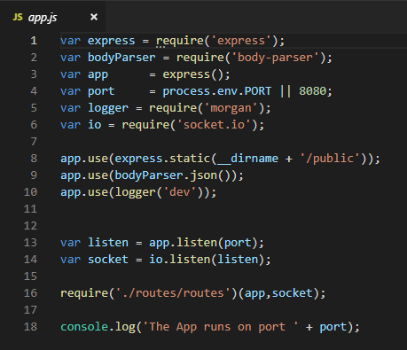

**Figure 11 - app.js**

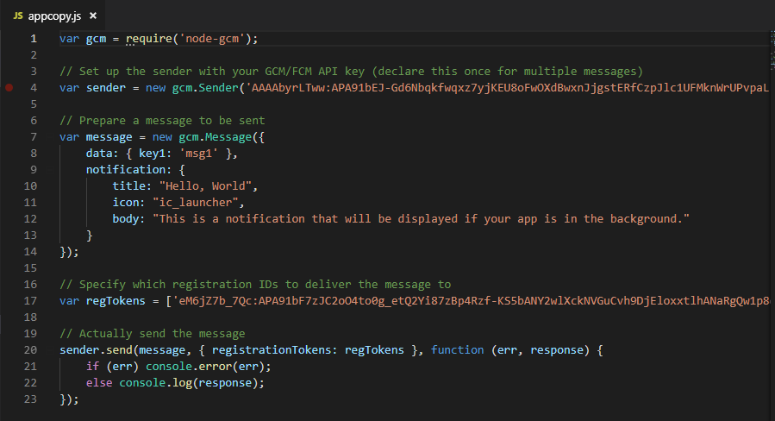

**Figure 12 - appcopy.js**

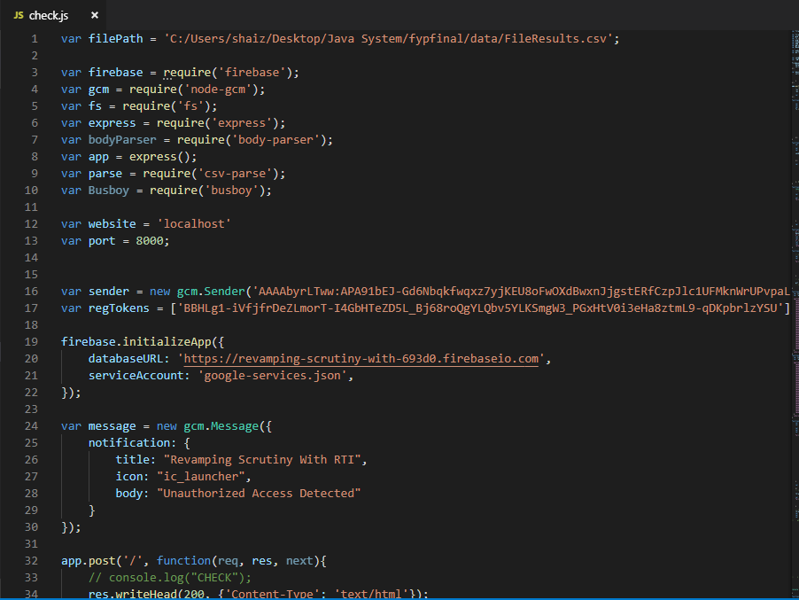

**Figure 13 - check.js**

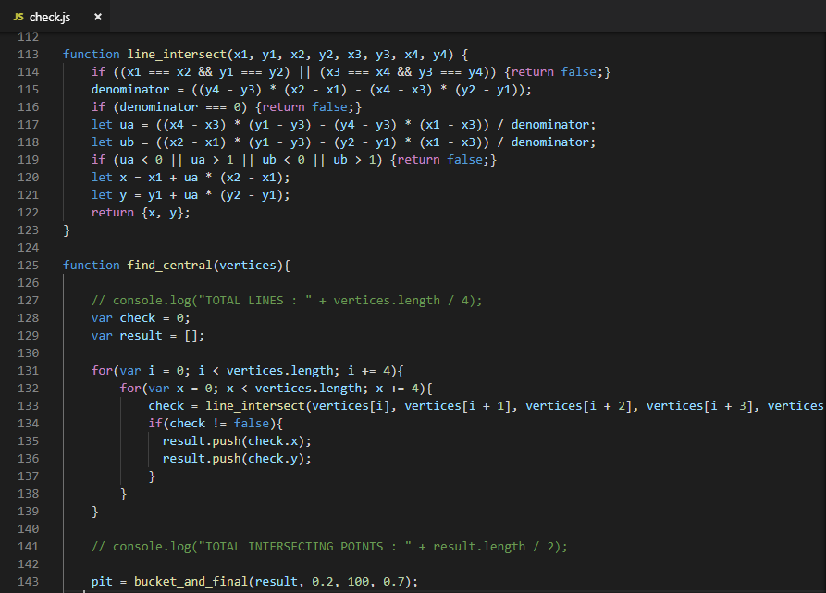

**Figure 14 - check.js (main algorithm)**

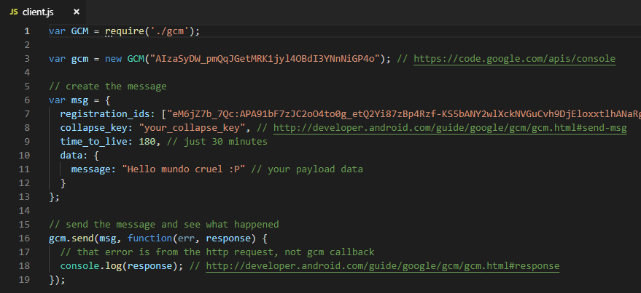

**Figure 15 - client.js**

**ANDROID APPLICATION SYSTEM DETAIL**

### **5.3.1 Classification**

This component act as means to display the calculated real-time results to the user.

### **5.3.2 Definition**

Android Studio is being used to analyze results, create the user interface and then display results.

### **5.3.3 Responsibilities**

The functionalities of the component are:

1. Receive the detected results
2. Push notification to prompt the user that there is an object
3. Get coordinates
4. Draw the moving object and represent real time activity

### **5.3.4 Constraints**

In order to use this part of the system it is necessary to install some of the libraries which are presented in detail in the implementation part of the report.

REPORT: REVAMPING SCRUTINY THROUGH RTI

### **5.3.5 Composition**

The subcomponents of this module are as follows:

* Set coordinates
  1. Display the grid on screen using X,Y coordinates
* Draw objects
* Get Coordinates

### **5.3.6 Uses / Interactions**

This particular component is used by the Firebase to push the updates information and in turn uses the server to get results and display those.

### **5.3.7 Resources**

A very important aspect is an active running internet connection to ensure the real time display of results.

### **5.3.8 Interface / Exports**

The code snippet is attached here as follows:

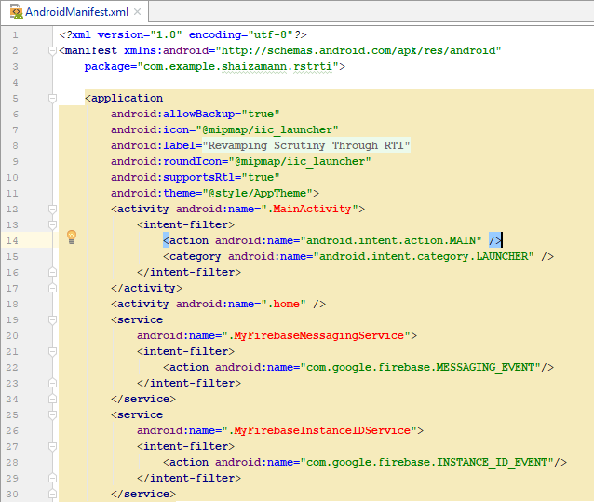

**Figure 16 - AndroidManifest.xml**

REPORT: REVAMPING SCRUTINY THROUGH RTI

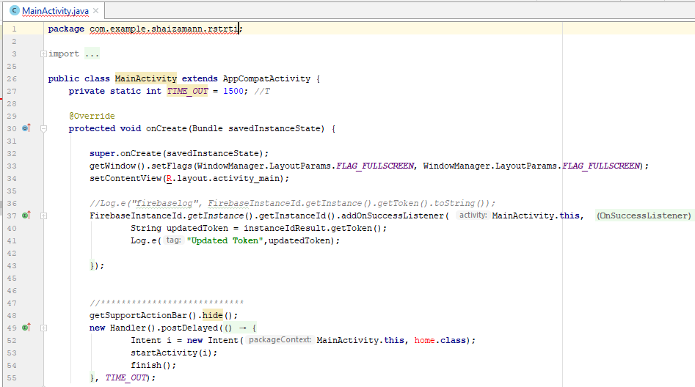

**Figure 17 - MainActivity.java**

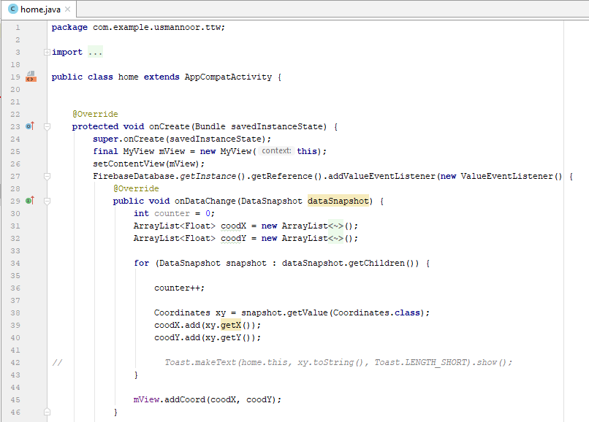

**Figure 18 - home.java**

REPORT: REVAMPING SCRUTINY THROUGH RTI

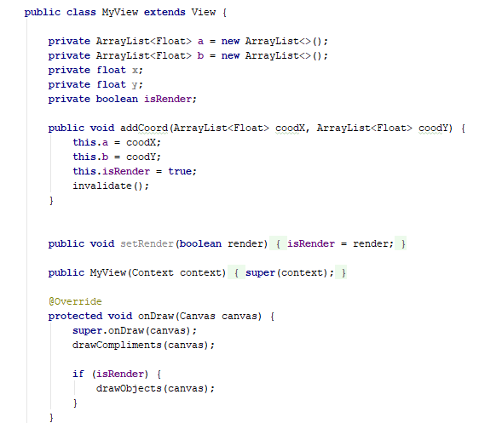

**Figure 19 - MyView class**

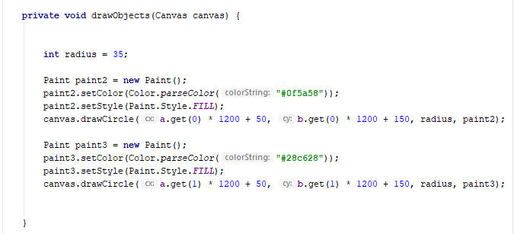

**Figure 20 - drawObjects procedure**

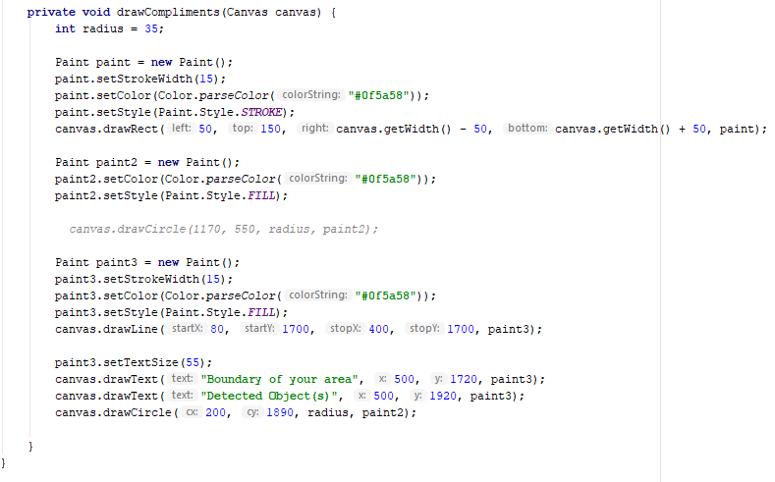

**Figure 21 - drawCompliments procedure**

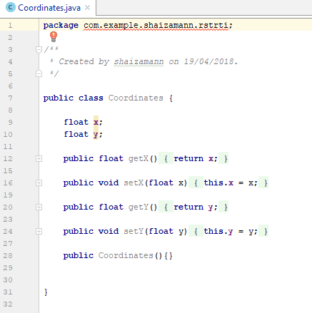

**Figure 22 - Coordinates.java**

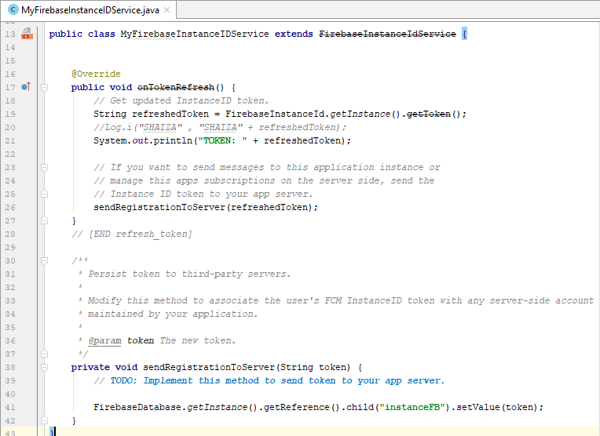

**Figure 23 - Firebase Integration I**

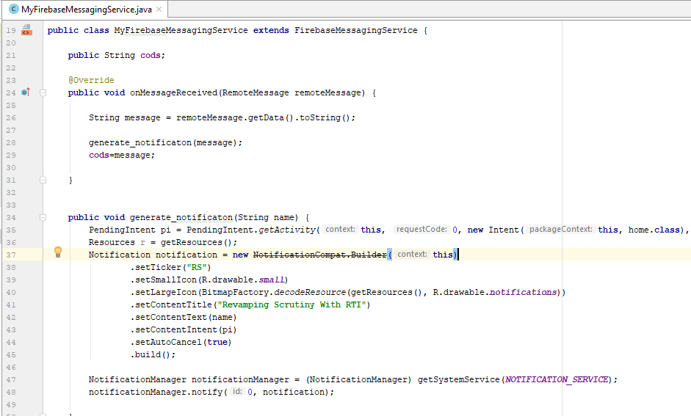

**Figure 24 - Firebase Integration II**

REPORT: REVAMPING SCRUTINY THROUGH RTI

**INTELLIJ SYSTEM DETAIL**

### **5.3.1 Classification**

This component act as means of loading dataset onto the NodeJS Server.

### **5.3.2 Definition**

IntelliJ is being used to upload dataset, manipulate RSS feeds from radio transmitters and forward it to NodeJS server..

### **5.3.3 Responsibilities**

The functionalities of the component are:

* Load dataset
* Devise coordinates
* Forward to server to be communicated to Android application

### **5.3.4 Constraints**

### **5.3.5 Composition**

The subcomponents of this module are as follows:

* Fyp.java
* SocketMessage.java

### **5.3.6 Uses / Interactions**

This particular component is used by the NodeJS server to push the updates information onto Firebase.

### **5.3.7 Resources**

A very important aspect is an active running internet connection to ensure the real time display of results.

### **5.3.8 Interface / Exports**

The code snippet is attached here as follows:

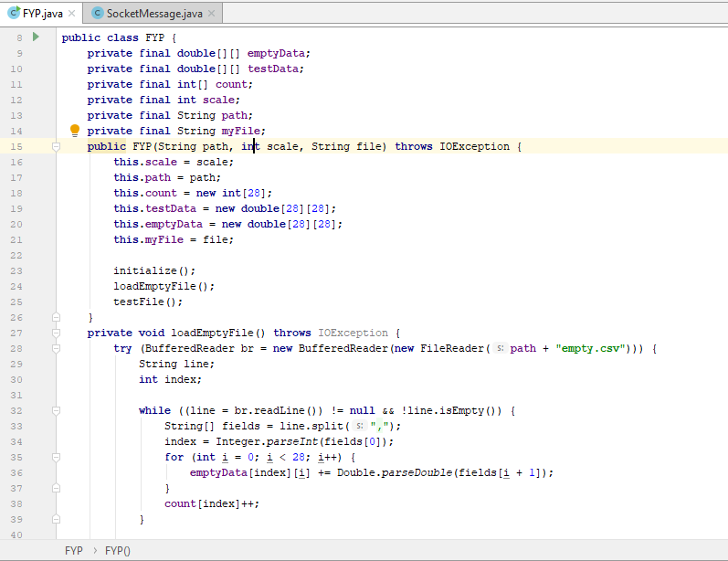

**Figure 25 - fyp.java**

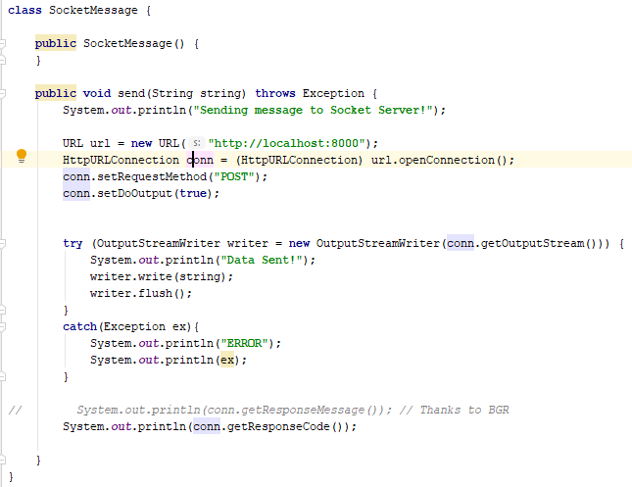

**Figure 26 - SocketMessage.java**

REPORT: REVAMPING SCRUTINY THROUGH RTI

# **5.3 CLASS DIAGRAM**

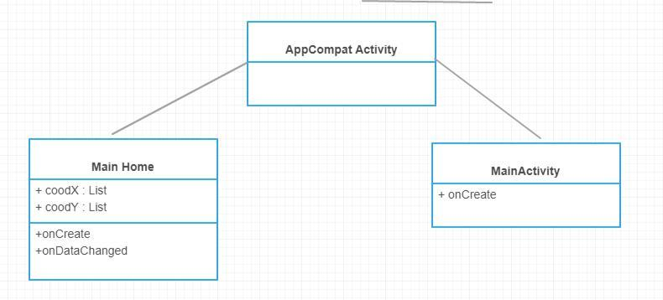



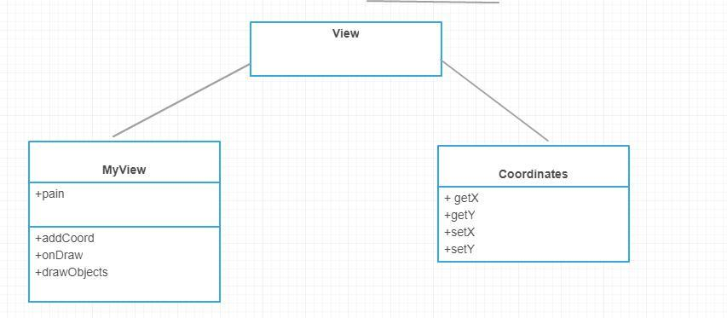

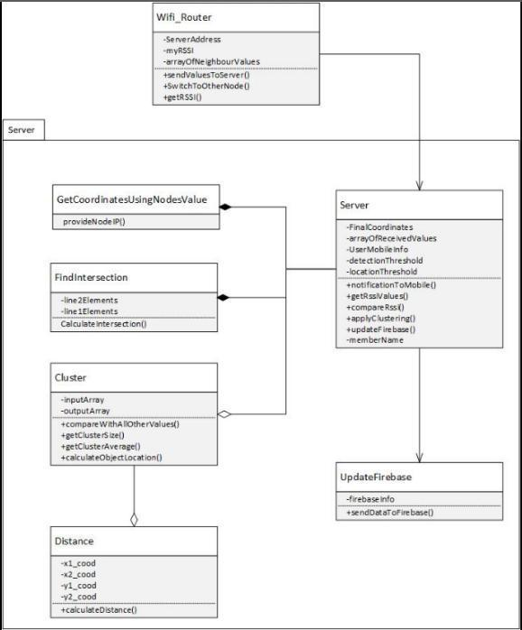

REPORT: REVAMPING SCRUTINY THROUGH RTI

***Chapter 6***

**IMPLEMENTATION AND DESIGN**

### **6.1 IMPLEMENTATION**

The implementation of the product is done mainly using node.js to develop the basic algorithm for calculation and android studio is used to develop an android application. Firebase is however used to collect the data that has been calculated and is used to prompt the android application to display a notification on the mobile phone‟s screen. Java-script is also being used to develop a webpage server that selects the file, dataset, on which the algorithm shall take place.

With reference to the system architecture, the values obtained are calculated by the implemented code which are then send to a centralized server for further result compilation. These results are sent to the database which acts as an intermediate between the node.js server and the android application. The Firebase server first sends the notification and then continuously sends the updated location of the object moving

Initially an array is created which contains the noise distortion, the cluster value, the average cluster value which is used when the RSS values are collected and the clusters are created. Two for loops are run for this process, first to traverse each node (point calculated) to determine the average number of closest points falling into that area. The next loop is to determine which clusters are the noise and are supposed to be discarded. This entire processing is carried out after the appropriate dataset is chosen from the web-page.

A number of java libraries are used and are mentioned as followed:

* FSM
* CSV
* CSV-parse
* Java.utils
* Busboy
* Math
* Parser
* Express
* GCM

### **6.2 TESTING**

The type of testing carried out for this project is unit testing. This is carried out on two scenarios which were used through-out to run the algorithm. Considering the overall accuracy of the system:

* Detection of Moving Object o Accuracy 100%
* Locating a single moving object o Accuracy 92%
* Locating moving object (>1)

1. Accuracy 60%

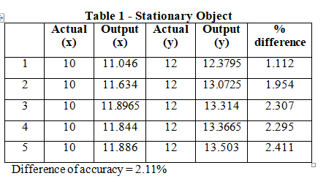

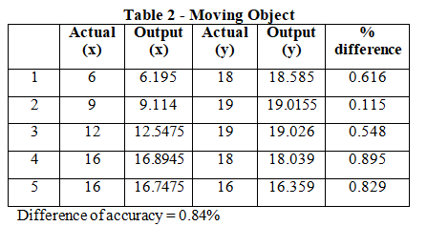

REPORT: REVAMPING SCRUTINY THROUGH RTI

***Chapter 7***

**RESULT AND DISCUSSION**

The experimental results revealed system's efficacy in d-etecting and positioning objects in an enclosed environment. The type of testing carried out for this project was unit testing. It was carried out on two scenarios which were used through-out the experiment to run the algorithm.

Considering the overall system, 100% accuracy was achieved in detection of moving objects. The system was able to locate a single moving object with 92% accuracy as opposed to 60% accuracy in locating more than one moving object, as depicted by the statistics shown in the tables below.

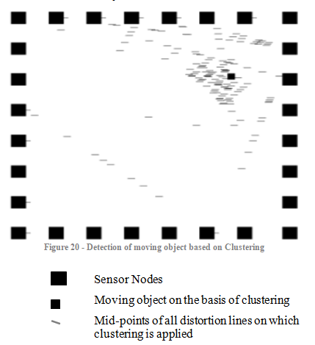

REPORT: REVAMPING SCRUTINY THROUGH RTI

# **7.1 Results**

### **7.1.1 Testing Result**

**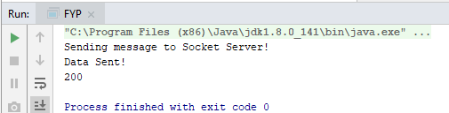**

**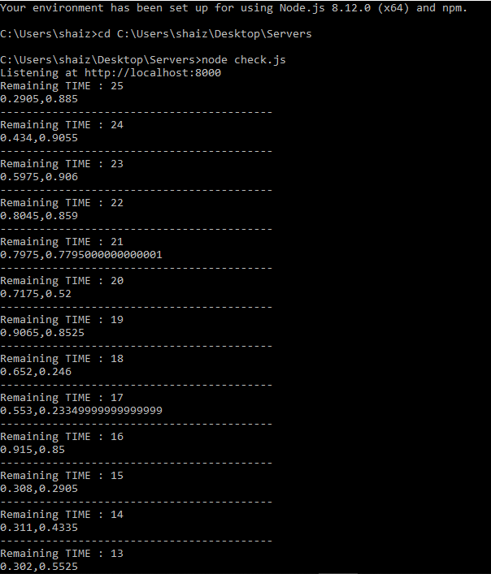**

**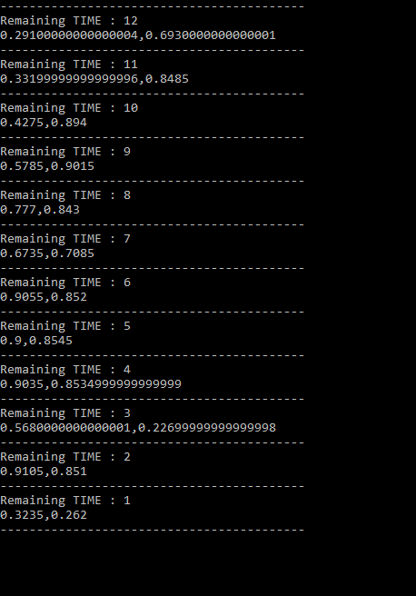**

REPORT: REVAMPING SCRUTINY THROUGH RTI

### **7.1.3 ANDROID APPLICATION INTERFACE RESULTS**

 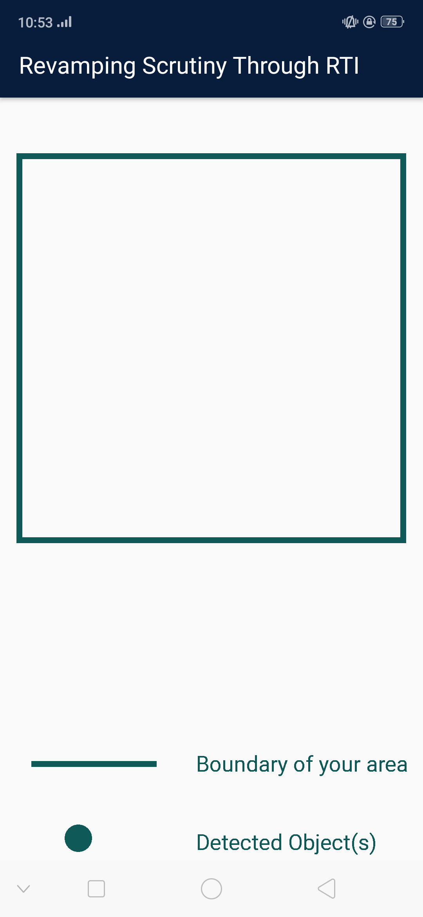

### **7.1.4 RESEARCH PAPERS**

As this final year project was research-based, two research papers have been produced at the end to be submitted in reputable conferences.

Research papers produced as per requirement of the FYP:

1. Technical Paper

2. Survey Paper

REPORT: REVAMPING SCRUTINY THROUGH RTI

***Chapter 8***

**CONCLUSION AND FUTURE WORK**

The project that has been developed currently is of sufficient use as it manages to produce accurate results. However, the use of already produced dataset set a limitation to compare our results with the collected results. Hence, the comparison of algorithms that we developed was done with various researches which fell under a similar category.

As mentioned earlier, the main purpose of the project was to ensure security and safety of individuals in a cost and energy efficient manner. Looking into the aspect of cost, the initial purchase of a few radio transmitters is expensive which can be overlooked as this is a onetime investment with an effectively working algorithm applied to it. We also managed to propose a solution that can be used in a variety of applications.

This research can be further carried out by initially improving the accuracy of localization for a single moving object and then considering the results for more than object entering into a specific area. This can be first of all done improving the clustering method and then introducing an alternative algorithm to eliminate noise. This will in turn eliminate any discrepancies caused in the result.

Training of the algorithm to ensure versatility can be done by performing experiments with the use of many transmitter in real-life scenarios will play a role to improve the results and the project overall. Since most of the researches follow the approach of developing a radio tomographic image, this can be added in along with the android application results to ensure a user-friendlier application especially in the case of obstructed areas.

REPORT: REVAMPING SCRUTINY THROUGH RTI

***Chapter 9***

**REFERENCES**

1. J.Wilson and Neil Patwari, “*Radio Tomographic Imaging with Wireless Networks*”, IEEE Transactions on Mobile Computing, vol. 9, no. 5, pp.621-32, January 2010.
2. J.Wilson and Neil Patwari, “*Radio Tomographic Imaging with Wireless Networks*”, IEEE Transactions on Mobile Computing, vol. 9, no. 5, pp.621-33, May 2010.
3. M. Rusli, M. Ali, N. Jamil, M. Din, "*An Improved Indoor Positioning Algorithm Based on RSSI-Trilateration Technique for Internet of Things (IOT)*", 2016 International Conference on Computer and Communication Engineering (ICCCE), 2016.
4. Javaid, R., Enam, R. and Qureshi, R., “*RSSI based Node Localization using Trilateration in Wireless Sensor Network*”, Bahria University Journal of Information & Communication Technologies, pp.58-64, December 2015.
5. A. Noertjahyana, I.A. Wijayanto, J. Andjarwirawan, "*Development of Mobile Indoor Positioning System Application Using Android and Bluetooth Low Energy with Trilateration Method*", 2017 International Conference on Soft Computing Intelligent System and Information Technology (ICSIIT), pp. 185-189, 2017.
6. M. Rudinac, P. P. Jonker, “*Saliency Detection and Object Localization in Indoor Environments*,” Proc. of the International Conference on Pattern Recognition, pp. 404–407, 2010.
7. Y.Zheng and A.Men, "*Through-Wall Tracking with Radio Tomography Networks Using Foreground Detection*," in *2012 IEEE Wireless Communications and Networking Conference (WCNC)*, Shanghai, China, 2012, pp. 3278-3283.
8. <https://www.popsci.com/technology/article/2012-07/seeing-through-walls-wireless-router>
9. Yang Zhao, Neal Patwari, Jeff M. Phillips, and Suresh Venkatasubramanian, “*Radio tomographic imaging and tracking of stationary and moving people via kernel distance*,” in Proc. of Information Processing in Sensor Networks (IPSN), April 2013. Website:https://span.ece.utah.edu/products.html